SRS Documentation
1.Abstract
“E-commerce using collaborative filtering” is basically a web-based platform is to provide a best way of searching of items in a e commerce site. It is a ERP system for xyz company which has various types of goods and they need every thing to be automated and customized to reduce the human work and need to expand their business to the internet. Other sub-objective is to make a survey and collect data how people think of using new e commerce and its uses. That helps the Researchers, Government for the study of human nature and behaviour in various ways.

2.Brief Description
“E-commerce using collaborative filtering” is basically a web-based platform where the way of searching items is made very easy and best at its cost. This is a ERP system for a xyz company. This company had a e-commerce website previously which not included any prediction technique and filtering. We are trying to improve(Totally full new design)UI and with collaborative filtering.
Admin can login in to the system using his default username and password. Admin job is to see overview what the users are likely towards and which items are most searched and which are least. The least item are usually avoided and removed from the website.
User first need to register in to the website by providing the details like name, address, phone number, gender ,DOB and email address. After successful registration user can login then search the products, Add products to cart and finally buy product.
Made an option to admin that if any product which not been seen or searched by the users those products create an notification to admin and admin finally remove those items which will makes an simple and effective e commerce deign and it also helps the user to search the items very effectively and easy. This feature helps in predicting the what products user usually search.
2.1Existing System
- The existing system had bad UI experience as surveyed thought the users.
- The system don’t have effective filtering concept involved.
- Always show irrelevant products which users not even interested and does not do any predicting job.

2.2Proposed System
- This system will have the predictive suggesting products for users which usually attracts the users.
- The collaborative filtering makes a better search when particular item/product is searched.
- The new UI will never crashes while users are surfing in the website.
- Any live update to done to the system is will not effect the users transactions.

3.Hardware/Software Requirements
3.1Hardware specifications
- Processor : Intel Core i3
- Processor speed : 1.8 GHz
- RAM : 2 - 4 GB
- Hard Disk Capacity : 250 GB-500GB

3.2 Software specifications
  - Operating System : Windows 7 and above
  - Technology : Python
  - Web Technologies : Html 5, JavaScript, CSS
  - IDE : PYCharm
  - Database : MySql

4. Functional and Non Functional Requirements
4.1 Functional Requirements
Admin Login
Administrator can login by using his/her set of usernames and passwords.
User Register
User must get registered by providing details like Name, Phone number, DOB, Address, Email-Id.
User Login
User must login with the details he/she provided at the time of registration.
4.2 Non Functional Requirements
Compatibility – This make ensure that the platform can be easily integrated with 3rd party systems.
Quality – The best e-commerce platforms you should insist that code is developed to a good quality standard(Indentation and comments).
Search – Search defining how quickly the system will return search results this decides how faster application works.
Security – It is important to specify the level of security that should be met such as the OWASP top 10.
Availability – defining the agreed uptime of the platform under normal conditions.
Version – the application will support a variety of versions in python and variety of web browser.
5. UML Diagrams
5.1 UseCase Diagram
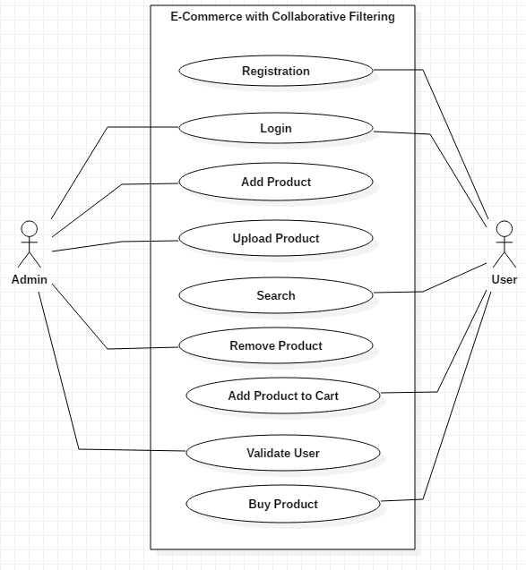
Registration: Users get registered to website using their required details like name, phone number ,address, e-mail username and password.
Login: Both user and admin will be login using their username and password respectively.
Add product: Admin can add the required product to the database.
Upload product details: Admin Update the existing product details.
Search: User search the product in the website.
Add product to cart : User adds Number of quantities of a product to the cart.
Buy Product : User buy the product saved in the cart and proceed to the payment.

5.2 Class Diagram
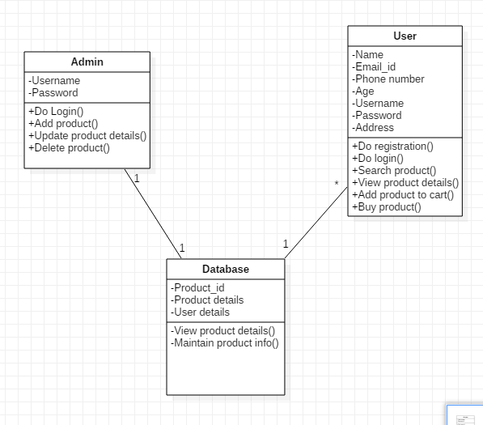

5.3 Sequence Diagram
Admin
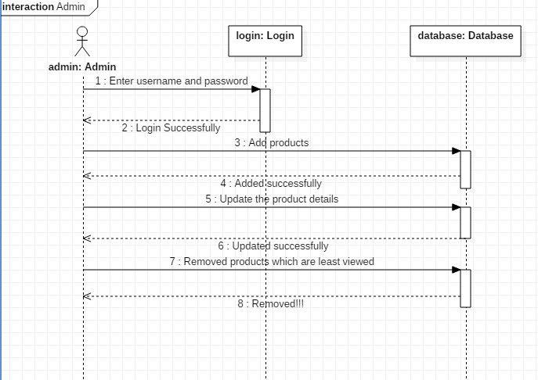
Admin: Here admin logins to the system with his default username and password. After successfully login he add and delete product to website via database. Admin can also update the details of the existing product details.

User
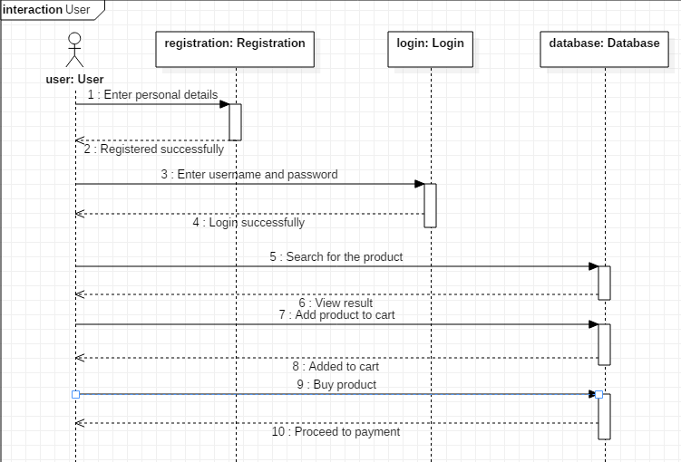
User: User first need to register in to the website by providing the details like name, address, phone number, gender , DOB and email address. After successful registration user can login then search the products, Add products to cart and finally buy product.

5.4 Activity Diagram
Activity of Admin
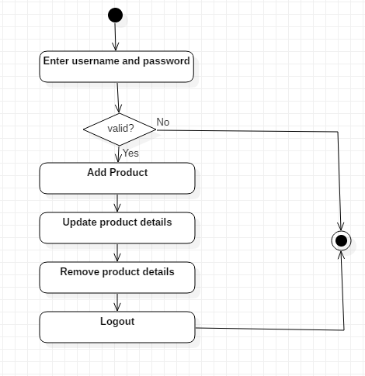

Activity of user
